A Study of the Dark Side of AI: Adversarial Attacks on Deep Learning Systems and Defense Mechanisms

Gaurav Sharma , Dr.Sreevani Maddukuri
Gaurav Sharma (student), INT.Mtech CSE Spec. Cyber Security, VIT Bhopal Dr.Sreevani Maddukuri(supervisor), Dr. Hemraj .S.Lamkuche(reviewer 1),Puspinder Singh Patheja(reviewer 2), School of Computing Science Engineering and Artificial Intelligence, VIT Bhopal

ABSTRACT
Convolutional image classifiers support many security and healthcare applications, but they can misclassify inputs when pixel values are altered slightly. A compact CNN was trained on CIFAR-10 and evaluated before and after FGSM perturbations. Clean test accuracy reached 72.54%. Under FGSM with epsilon 0.03 the value fell to 7.34%. A second training phase with adversarial batches raised attacked accuracy to 28.38% at the same epsilon while clean accuracy became 65.15%. Graphs, a confusion matrix, and sample image comparisons document the change between the two trained versions.

Introduction
Deep learning systems now appear in banking software, diagnostic imaging, and vehicle perception modules. Learning is driven by gradient updates on training data. The same gradient information can be applied in reverse to craft inputs that force an incorrect class label. Such inputs often remain visually similar to the originals, which creates a security concern when models accept external data without additional checks.

The project evaluates FGSM impact on a CIFAR-10 CNN and measures whether adversarial training improves stability. A baseline network was trained and tested on clean images. Adversarial examples were then generated for epsilon values 0.01, 0.03, 0.05, and 0.10. A robust variant was produced by including perturbed samples during training. Accuracy tables, epsilon curves, confusion matrix output, and visual samples were collected for both models.

The work presents the following outcomes:
A CNN classifier designed and trained on the CIFAR-10 benchmark.
- FGSM attack evaluation across four epsilon settings on the baseline model.
- Adversarial retraining to obtain a second model with altered loss exposure.
- Quantitative and graphical comparison between baseline and robust networks.
- Literature Review
Szegedy et al. and Goodfellow et al. reported that neural networks may output wrong classes with high confidence when inputs receive very small perturbations. The effect has been observed across multiple architectures and datasets and is linked to sensitive decision regions in high-dimensional input space.

Goodfellow et al. defined FGSM as a single-step gradient-sign attack suitable for baseline robustness testing. Later methods such as PGD and Carlini-Wagner provide stronger attacks, yet FGSM remains common in introductory experiments. Published results also show that strong clean accuracy does not guarantee resistance under perturbation.
Adversarial training, discussed by Madry et al., exposes models to perturbed samples during learning and often improves attacked accuracy at a small clean-data cost. Broader AI security literature also covers poisoning, model extraction, and privacy leakage. The present experiments limit scope to a compact CNN on CIFAR-10 with FGSM as the sole attack method so that each stage remains traceable.

Methodology
The pipeline included dataset preparation, CNN training, FGSM generation, adversarial retraining, and comparative evaluation.

Dataset
Experiments relied on the CIFAR-10 dataset containing 32×32 RGB images in ten classes. The standard split of 50,000 training and 10,000 testing images was used. Classes include airplane, automobile, bird, cat, deer, dog, frog, horse, ship, and truck. Data were loaded through Torchvision and normalized before network input.
Convolutional Neural Network Architecture
The CNN contains two convolution layers (3→32 and 32→64 channels), a 2×2 max pooling layer, and two fully connected layers (4096→512→10). Training employed the Adam optimizer at learning rate 0.001 with cross-entropy loss.
Layer 1: convolution with 3 input channels, 32 filters, and 3×3 kernel.

Layer 2: convolution with 32 input channels, 64 filters, and 3×3 kernel.

Pooling: 2×2 max pooling after the convolution stack.
Fully connected head: 4096 features to 512 units, then 512 units to 10 outputs.
Fast Gradient Sign Method (FGSM)

FGSM forms adversarial inputs by adding epsilon multiplied by the sign of the input gradient of the loss. The relation used is x_adv = x + epsilon * sign(grad_x loss). Epsilon values 0.01, 0.03, 0.05, and 0.10 were tested.

Adversarial Training

- During adversarial training, each batch contained clean images and FGSM perturbations with unchanged labels. The robust model retained the baseline architecture. Both models were evaluated on the same test images and attack configurations.
- Evaluation Metrics
- Evaluation covered clean accuracy, FGSM accuracy, multi-epsilon plots, confusion matrix results, and visual inspection of selected adversarial samples.

Experimental Setup
Code was developed in Python with PyTorch on a Windows system using Visual Studio Code and a virtual environment. Torchvision provided dataset access, Matplotlib generated plots, and NumPy with Scikit-learn supported numerical and confusion matrix computation.
Software stack:
* PyTorch
* Torchvision
* Matplotlib, NumPy, Scikit-learn
CNN Training Configuration
Baseline training parameters were Adam optimizer (lr = 0.001), batch size 32, cross-entropy loss, and the full 50,000-image training set. Test accuracy reached 72.54%.

FGSM Attack Configuration

FGSM attacks were applied at inference with epsilon values 0.01, 0.03, 0.05, and 0.10 for both saved models using the same evaluation script.
The chosen epsilon range covers low, moderate, and higher perturbation levels while keeping smaller values difficult to detect visually.

Adversarial Training Configuration
The robust model trained for 10 epochs with FGSM at epsilon 0.03 during learning, combined clean and adversarial cross-entropy loss, and Adam at lr = 0.001.
- Generated Artifacts

- Generated outputs include training curves, FGSM comparison charts, epsilon robustness plots, adversarial image figures, and a confusion matrix.

Results and Discussion
  - On unperturbed test data the baseline CNN achieved 72.54% accuracy. Figure 1 shows training accuracy across epochs.
Impact of FGSM Adversarial Attacks
Baseline FGSM results were 23.13% at epsilon 0.01, 7.34% at 0.03, 3.35% at 0.05, and 1.04% at 0.10. Accuracy therefore dropped from 72.54% to 7.34% at epsilon 0.03, indicating high vulnerability to small perturbations.
Visual comparison showed little apparent difference between original and perturbed images despite changed predictions.
In one recorded sample the clean input was classified as class 3 and the perturbed input as class 5.

After adversarial training the robust model reached 65.15% clean accuracy, about seven percentage points below the baseline.

Under identical FGSM settings the robust model achieved 49.87% at 0.01, 28.38% at 0.03, 16.09% at 0.05, and 4.63% at 0.10. At epsilon 0.03 accuracy improved from 7.34% to 28.38% without changing architecture or dataset.
The observed clean-accuracy reduction alongside higher attacked accuracy matches patterns reported for adversarial training in prior publications.

Parameter | Value
Optimizer | Adam
Learning Rate | 0.001
Loss Function | Cross Entropy Loss
Batch Size | 32
Dataset | CIFAR-10
Training Images | 50,000
Testing Images | 10,000

Figure 6. FGSM Accuracy Comparison Between Standard CNN and Adversarial Trained CNN.

Parameter | Value
Adversarial Attack | FGSM
Training Epsilon | 0.03
Epochs | 10
Optimizer | Adam
Learning Rate | 0.001
Loss Function | Combined Clean And Adversarial Loss

A confusion matrix was prepared to examine class-wise misclassification.

Most errors appeared between visually similar pairs such as cat and dog or automobile and truck, which is expected at 32×32 resolution.
No class was entirely eliminated from correct predictions; errors were concentrated in related categories.

  - The baseline CNN performs adequately on clean CIFAR-10 data but degrades sharply under FGSM. Adversarial training recovers part of that performance while lowering clean accuracy slightly. For deployments that accept external images, robustness should be considered during training rather than added later.

Epsilon | Accuracy(%)
0.01 | 23.13
0.03 | 7.34
0.05 | 3.35
0.10 | 1.04

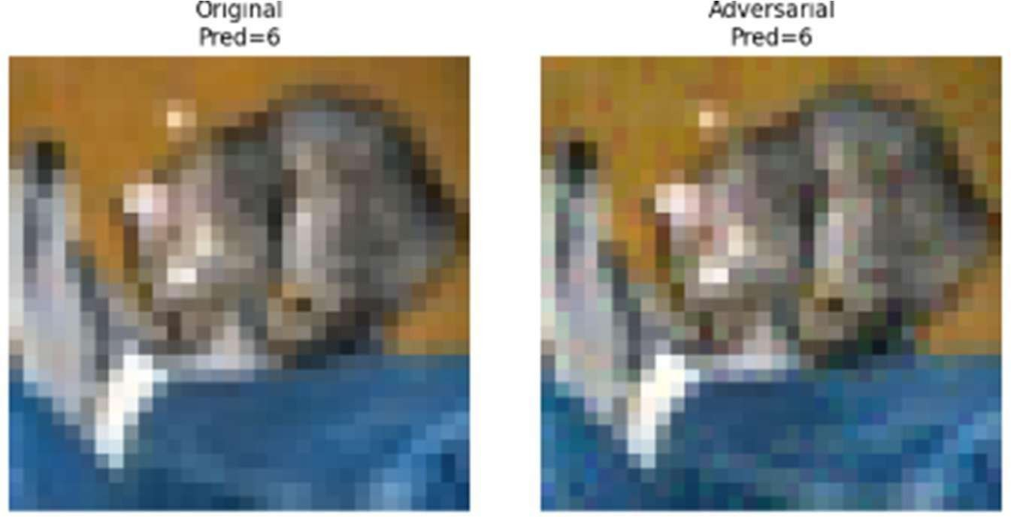

Epsilon | Robust Accuracy (%)
0.01 | 49.87
0.03 | 28.38
0.05 | 16.09
0.10 | 4.63

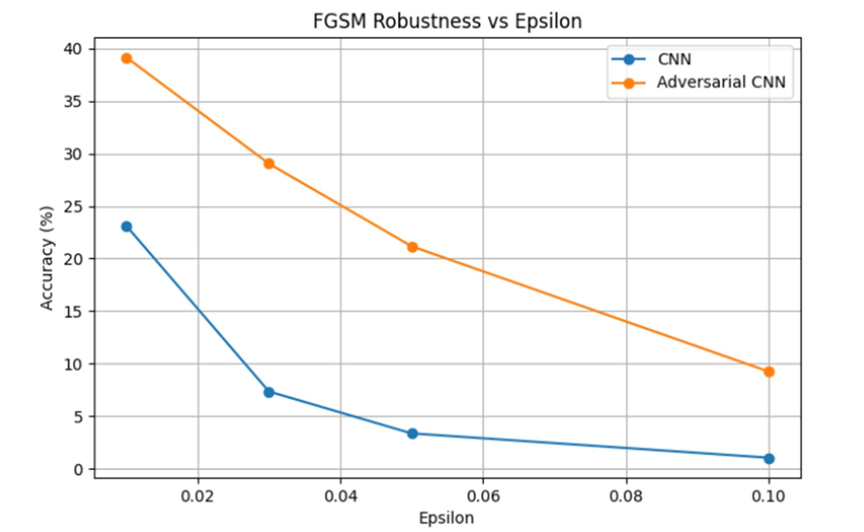

Metric | Standard CNN | Robust CNN
Clean Accuracy | 72.54% | 65.15%
FGSM Accuracy (ε=0.03) | 7.32% | 28.38%

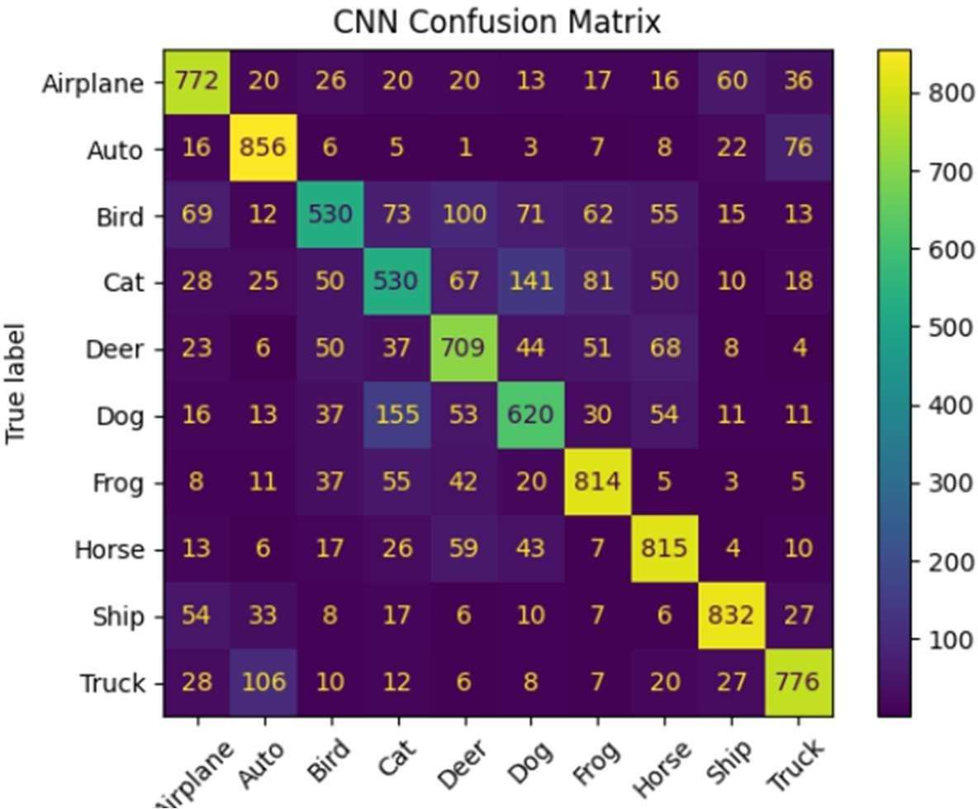
Figure 7. Confusion Matrix of CNN Classification Results

Limitations
Results are limited to one shallow CNN, the CIFAR-10 dataset, and FGSM attacks. Stronger methods such as PGD or Carlini-Wagner may produce different outcomes. Additional tests on deeper networks and larger datasets are needed before extending these findings to production settings.

Conclusion
FGSM attacks were applied to a CIFAR-10 CNN and adversarial training was used as a defense. Clean accuracy changed from 72.54% to 65.15%, while attacked accuracy at epsilon 0.03 changed from 7.34% to 28.38%. The results support including robustness objectives when models operate on potentially manipulated inputs.

Future Work
Further study may cover PGD and Carlini-Wagner attacks, certified defense methods, ResNet and VGG architectures, larger datasets, and domain-specific evaluation in cybersecurity, medical imaging, and autonomous systems.

9.References
- I. J. Goodfellow, J. Shlens, and C. Szegedy, “Explaining and Harnessing Adversarial Examples,” International Conference on Learning Representations (ICLR), 2015.
- A. Krizhevsky, “Learning Multiple Layers of Features from Tiny Images,” University of Toronto, Technical Report, 2009.
- Y. LeCun, Y. Bengio, and G. Hinton, “Deep Learning,” Nature, vol. 521, no. 7553, pp. 436– 444, 2015.
- N. Papernot et al., “Practical Black-Box Attacks against Machine Learning,” ACM Asia Conference on Computer and Communications Security, 2017.
- A. Madry et al., “Towards Deep Learning Models Resistant to Adversarial Attacks,” International Conference on Learning Representations (ICLR), 2018

